Name : Bhatt Astha Arpit

Enrollment : 196140316006

IT 6 Advance Java Programming

**SERVLET PRACTICALS**

1. Write a Servlet code to print “Hi”.

* HTML File.

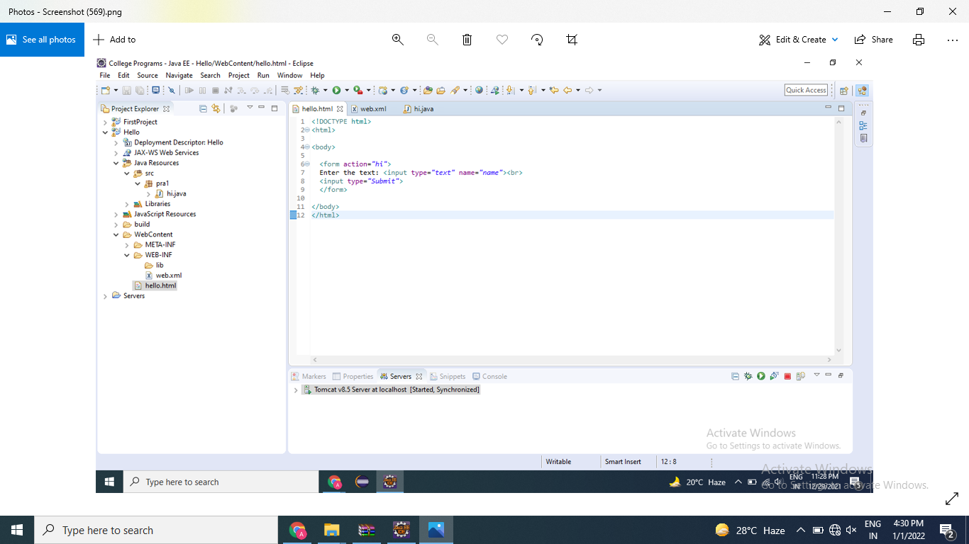

* JAVA File

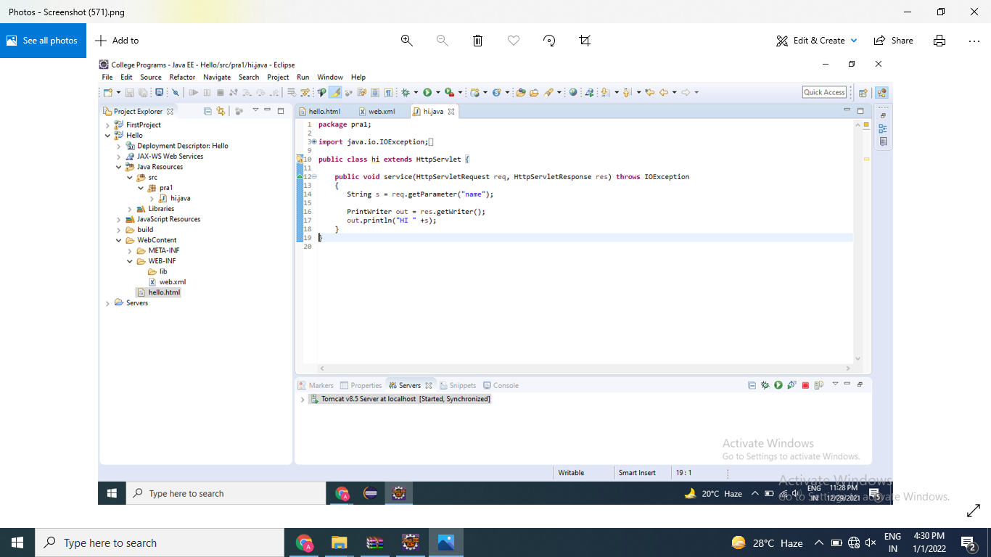

* Web.xml

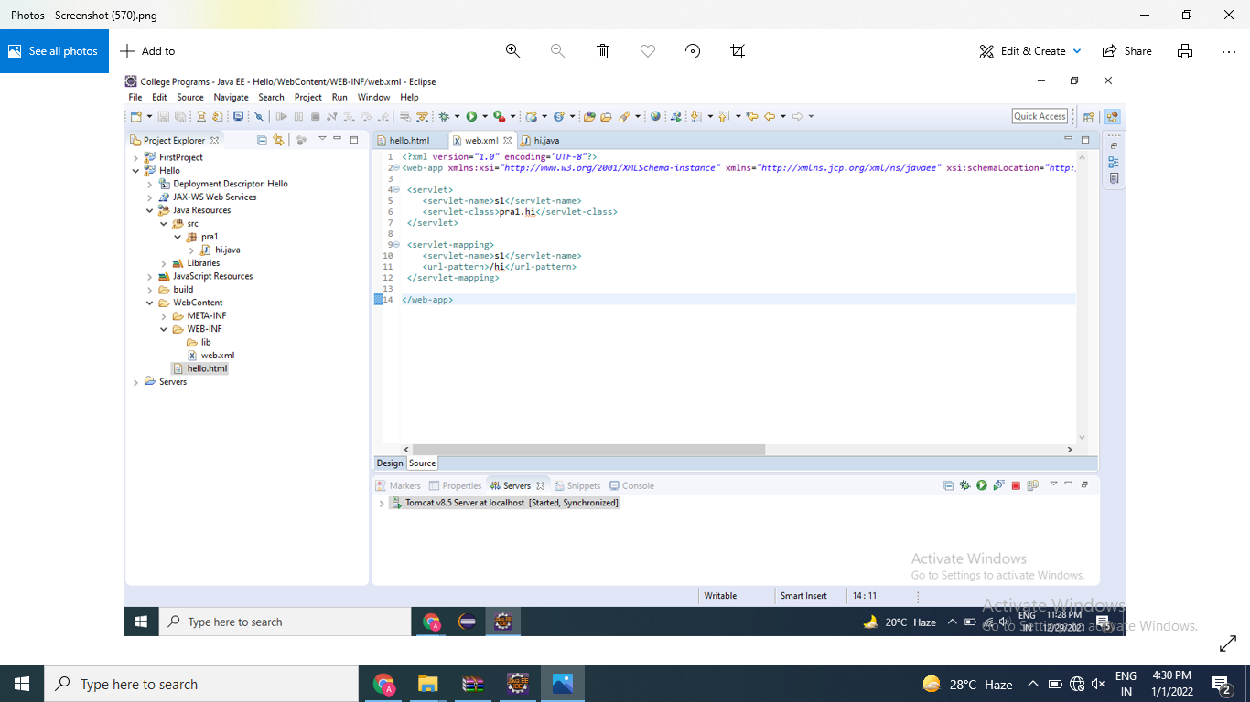

* Output :-

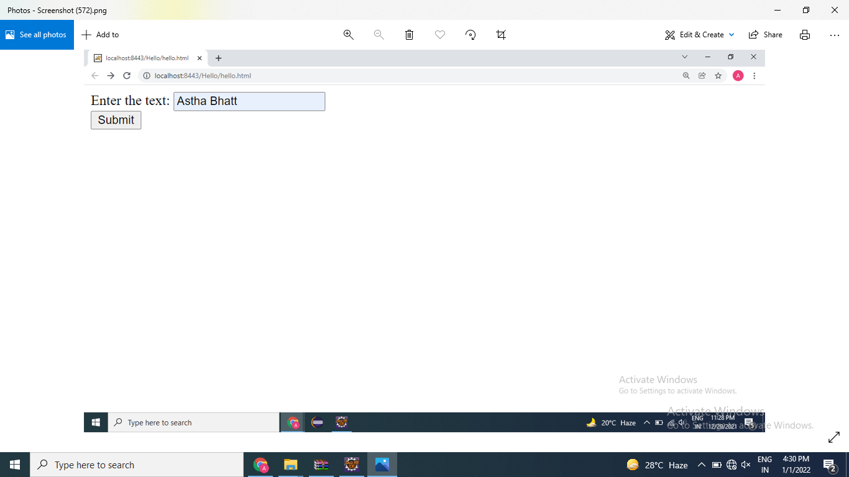

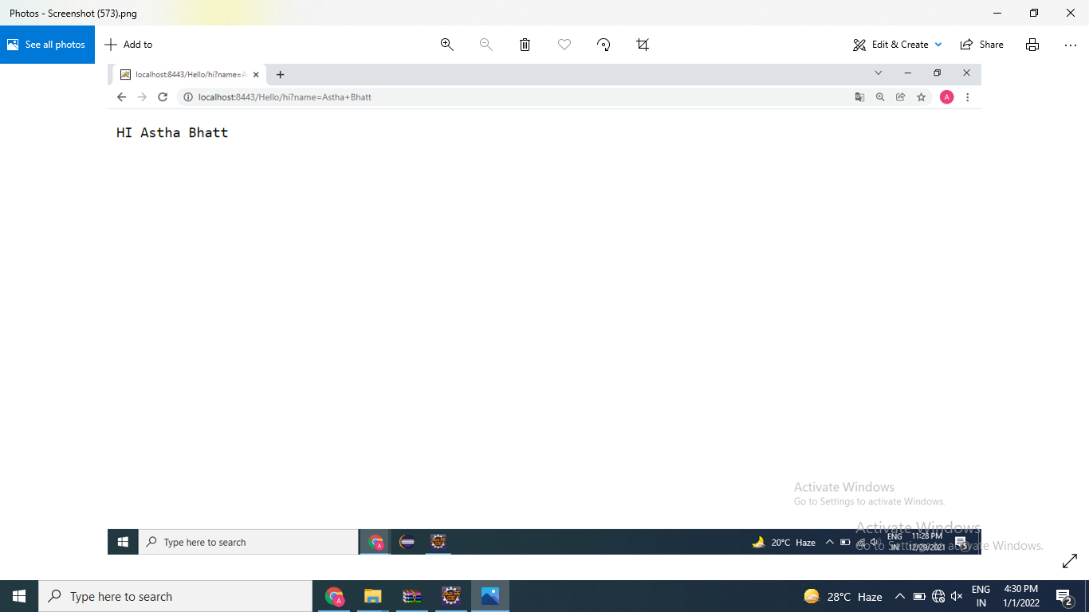

1. Write Servlet code to add two numbers

* HTML File

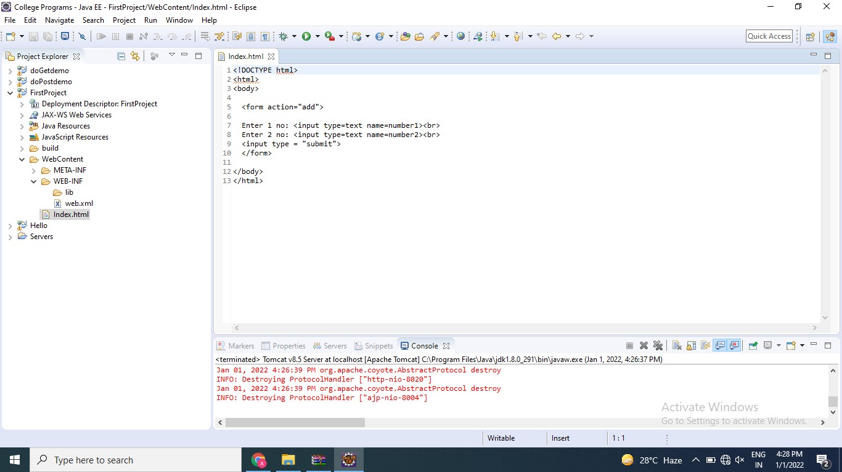

* JAVA File

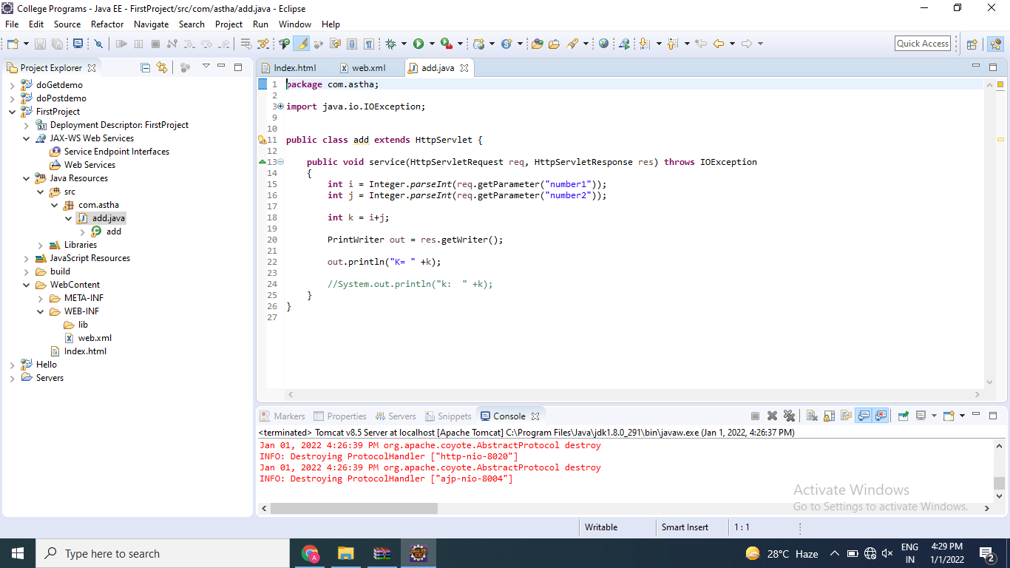

* Web.xml

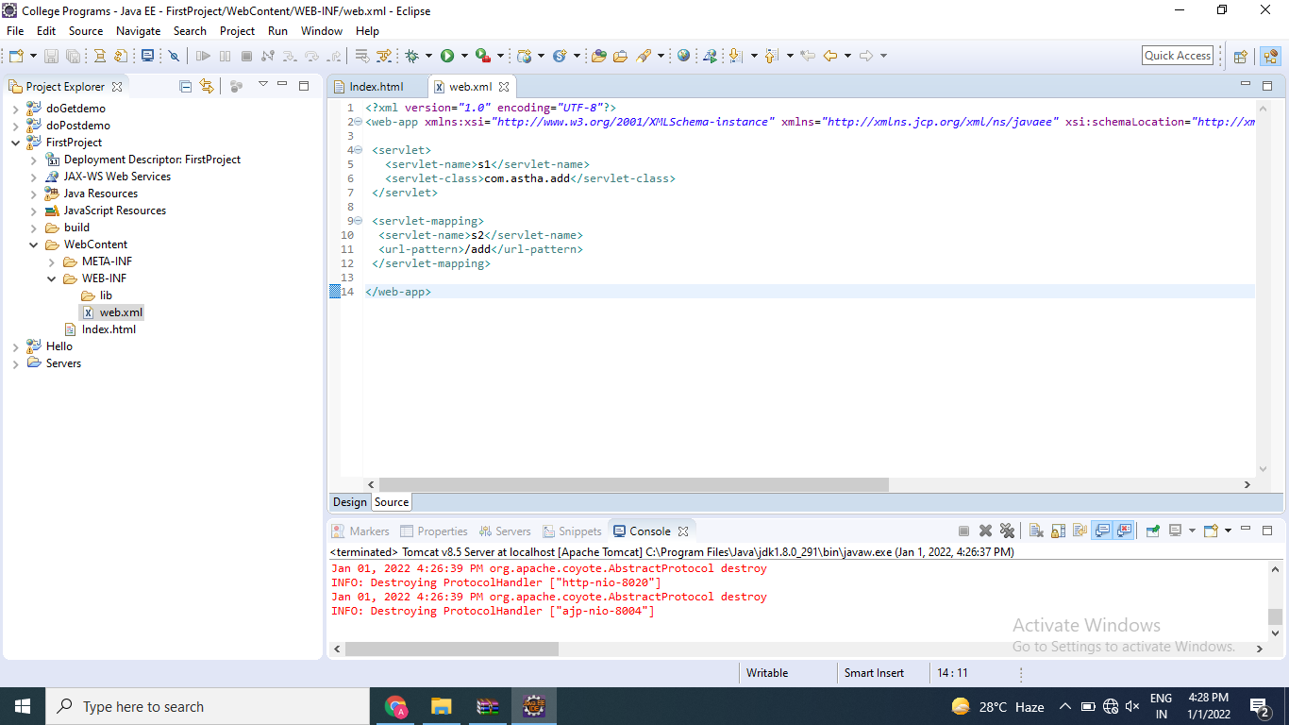

1. Write an HTML code to create login form having one submit button, two textboxes labeled as Login name and Password as respectively. Write a Servlet class named as ReadParameter to read these two parameters and display entered parameters values on the page using doGet() method when user clicked on submit button.

* HTML File

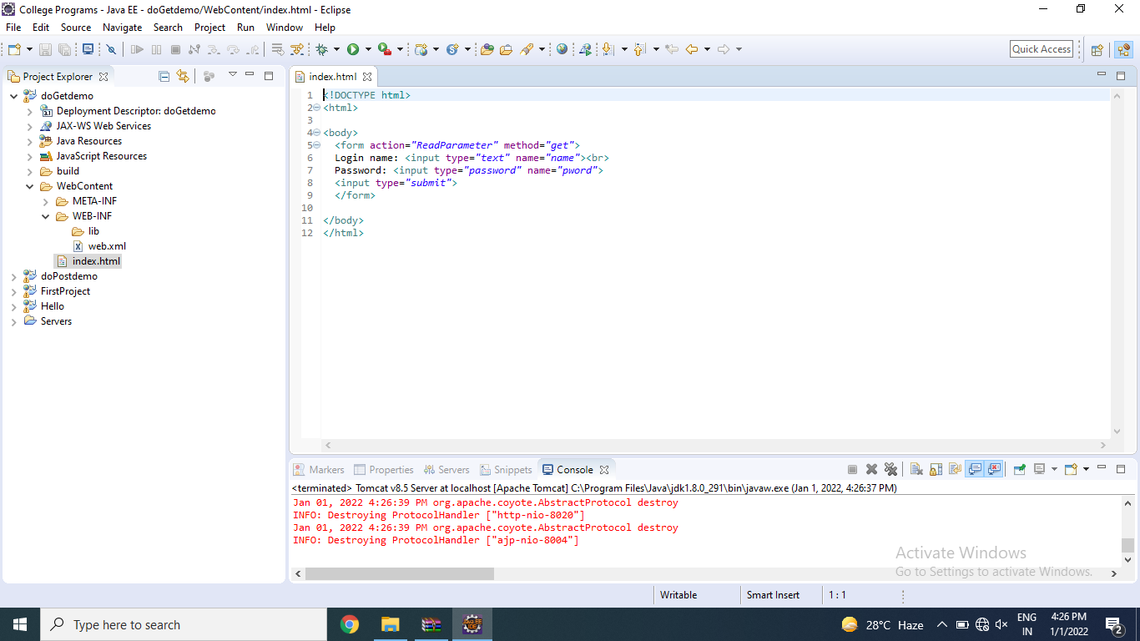

* JAVA File

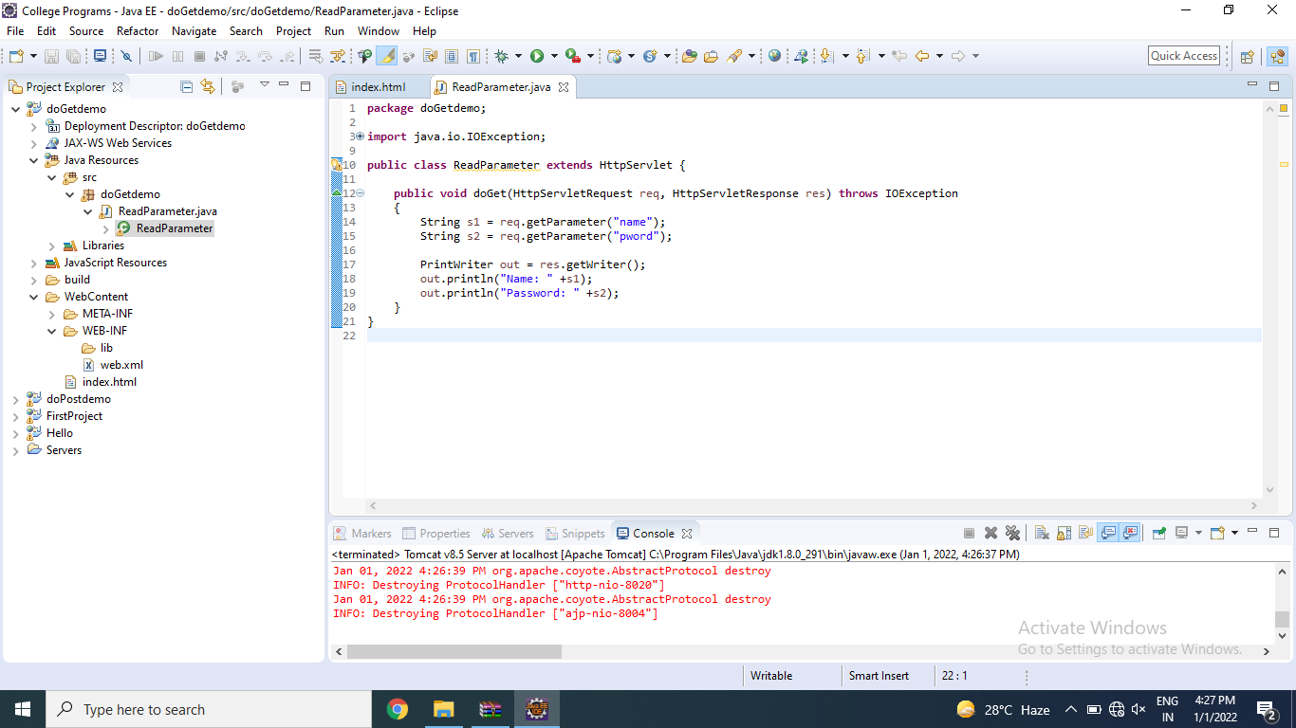

* Web.xml

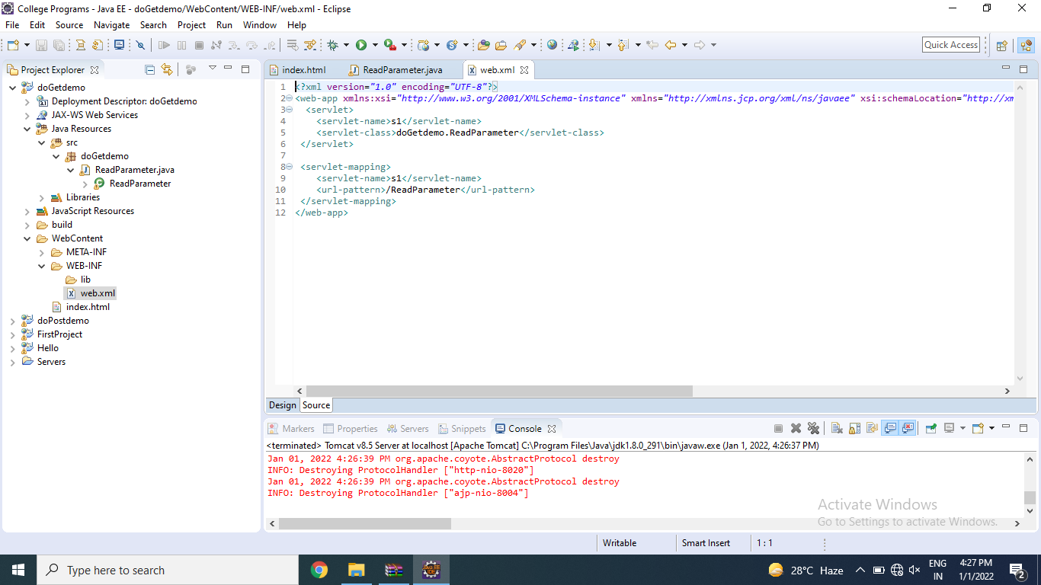

4)Write an HTML code to create login form having one submit button , two textboxes labeled as Login and Password as respectively. Write a Servlet class named as ReadParameter to read these two parameters and display entered parameters values on the page using doPost() method when user clicked on submit button.

- HTML File

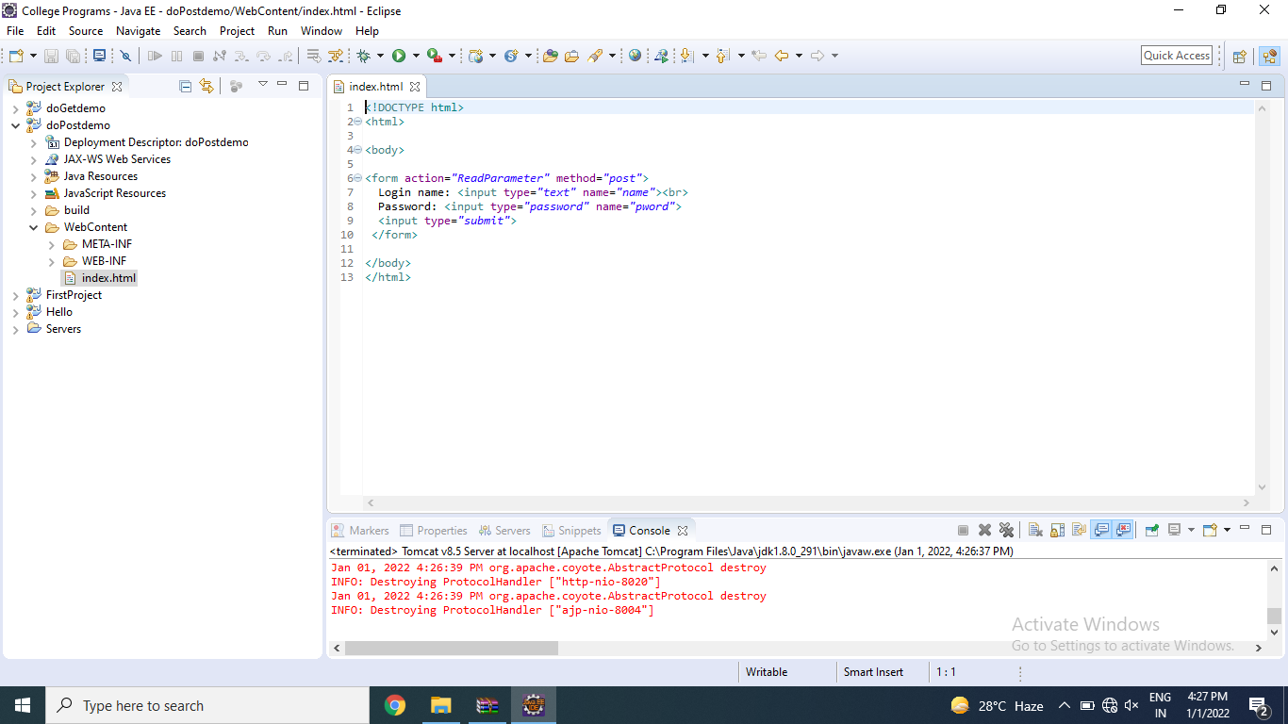

* JAVA File

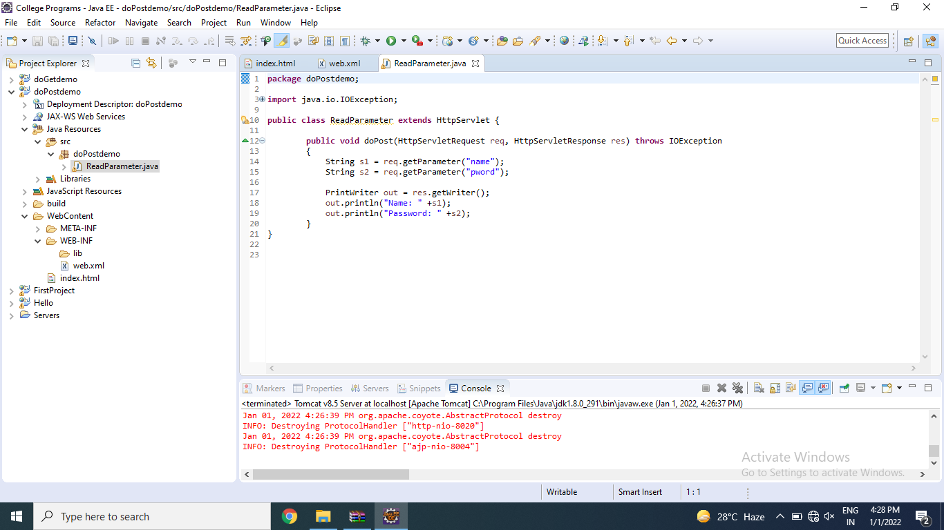

* Web.xml



